Go to https://ndsc.pyvot.com/welcome
Click on the Sign In tab at the top right.
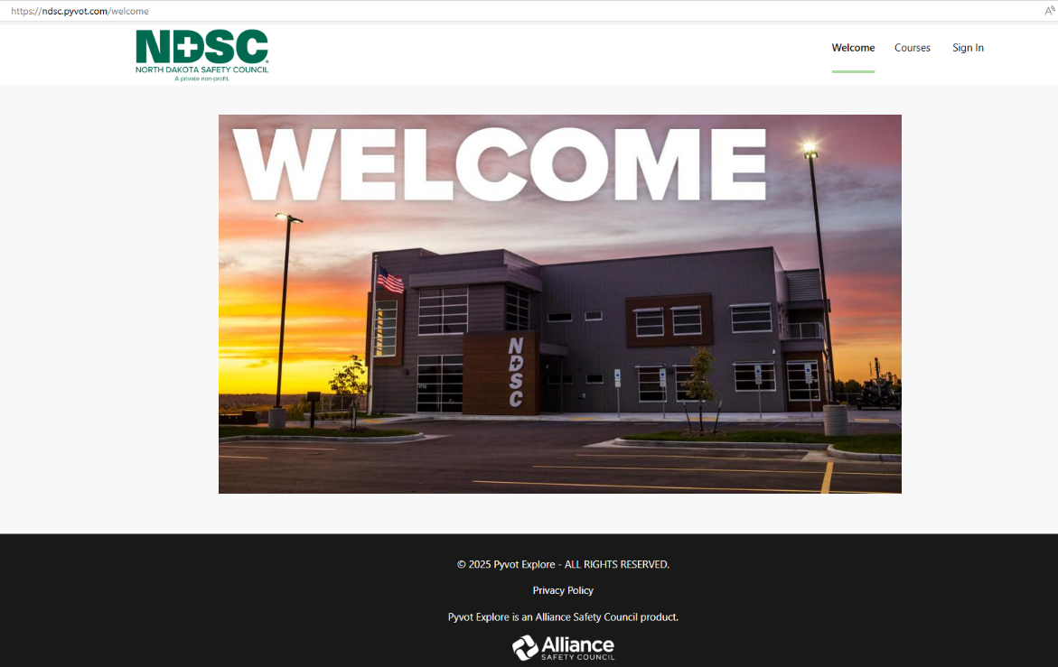

Select - Create an Account.
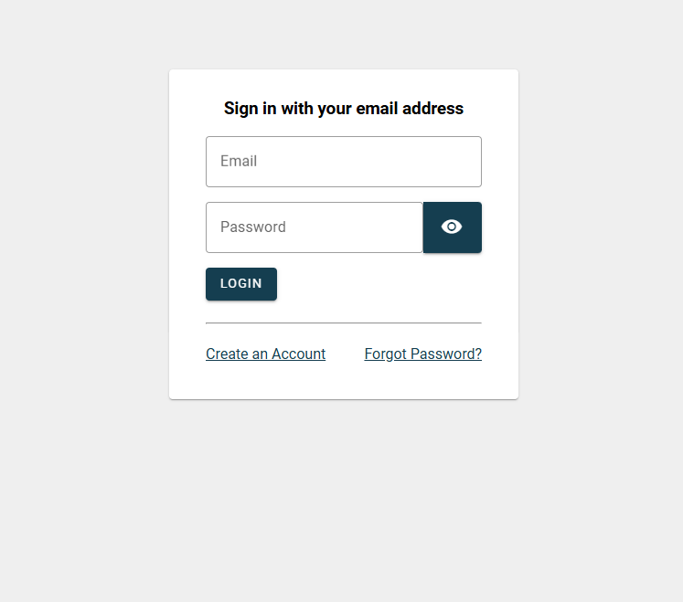

Fill out the sign-up form and create your password.
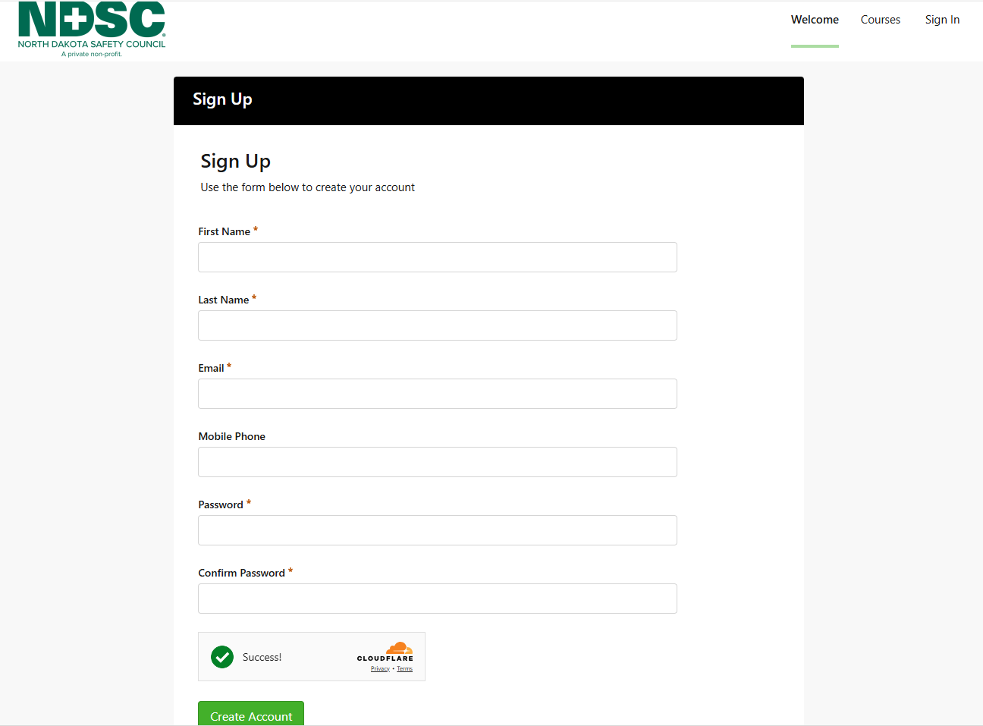

Agree to the Terms of Use.
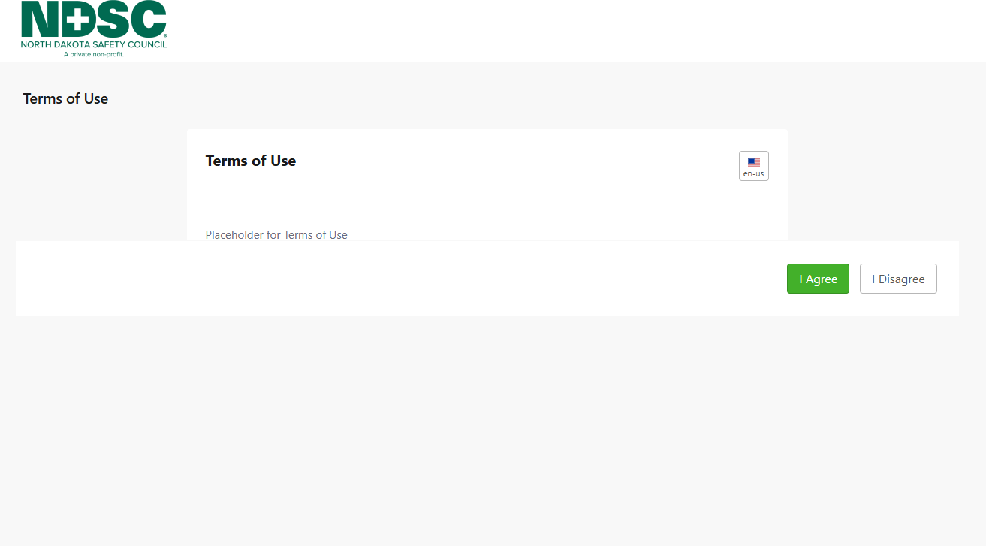

Click the Courses tab at the top.
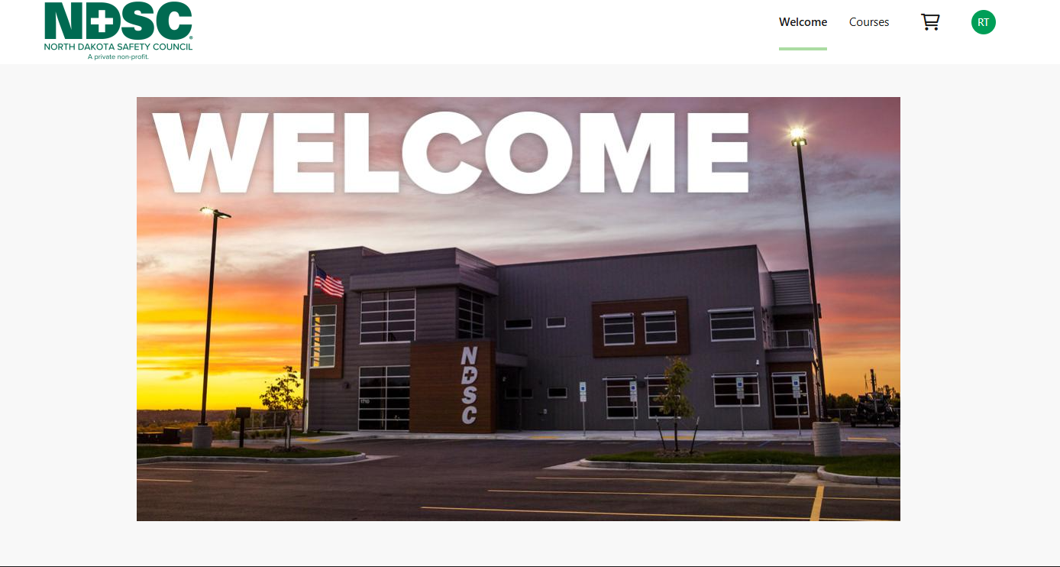

Select the course you want by clicking on its thumbnail image.
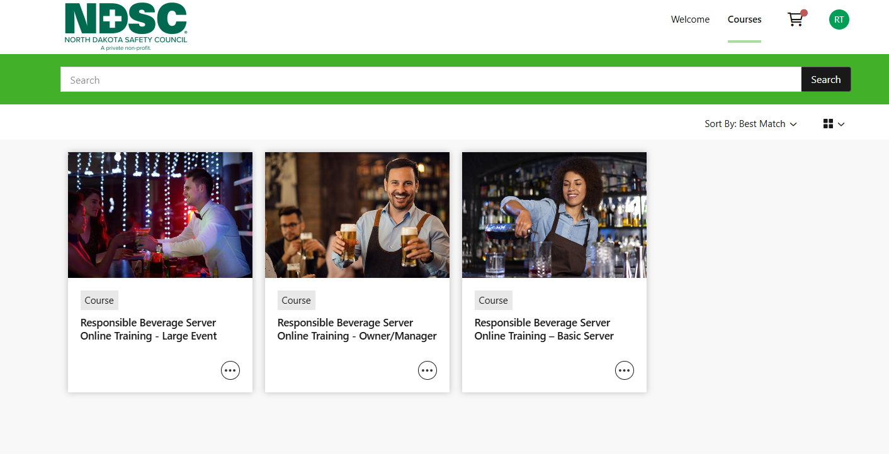

Click Add to Cart.
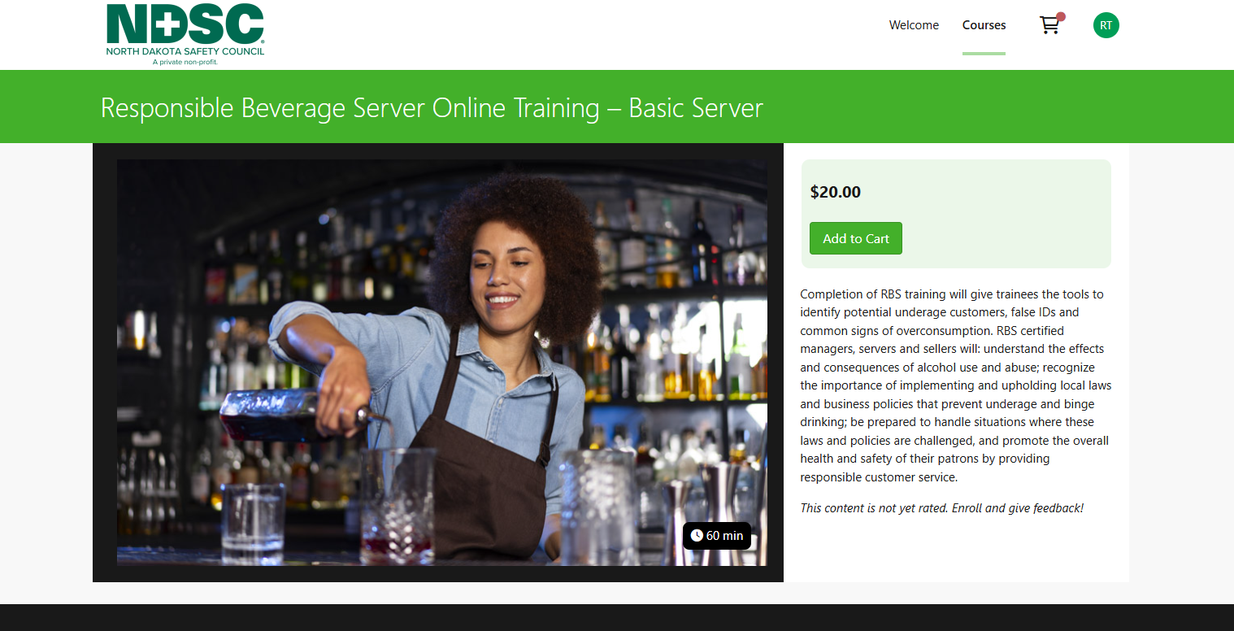

Click Check Out Now.
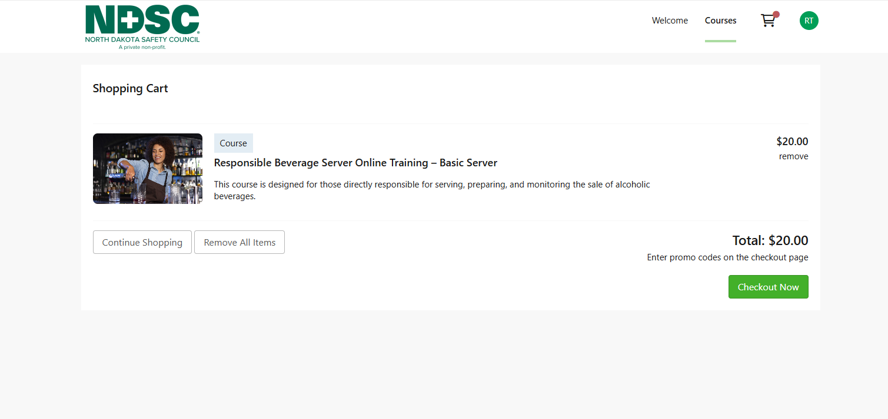

Enter your Payment and Billing Information, then complete the purchase.
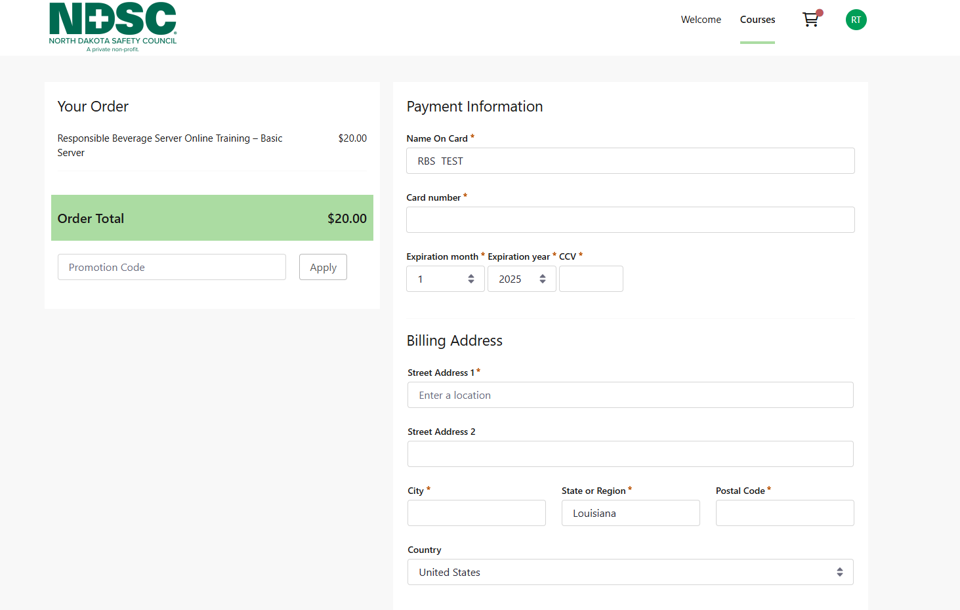
Once enrolled, click View Course.
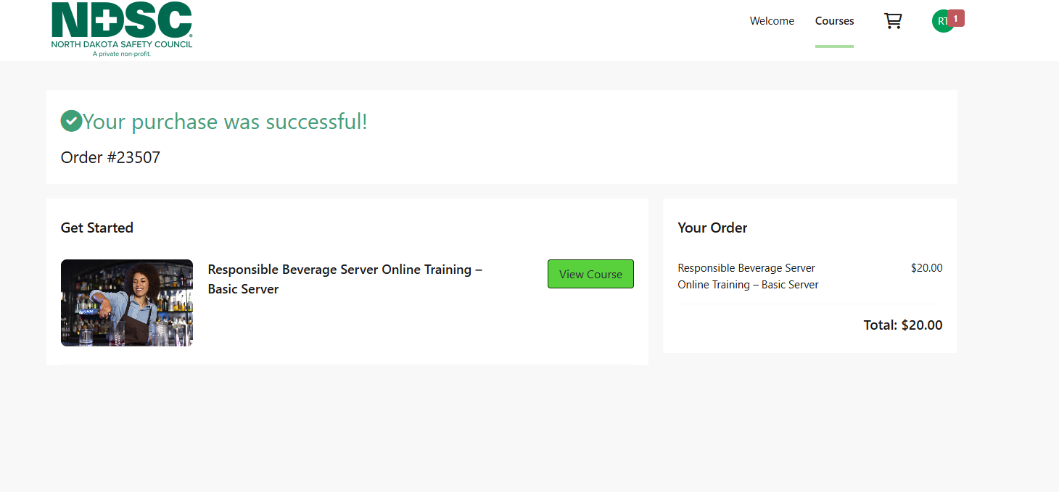

Click Launch Course to begin.
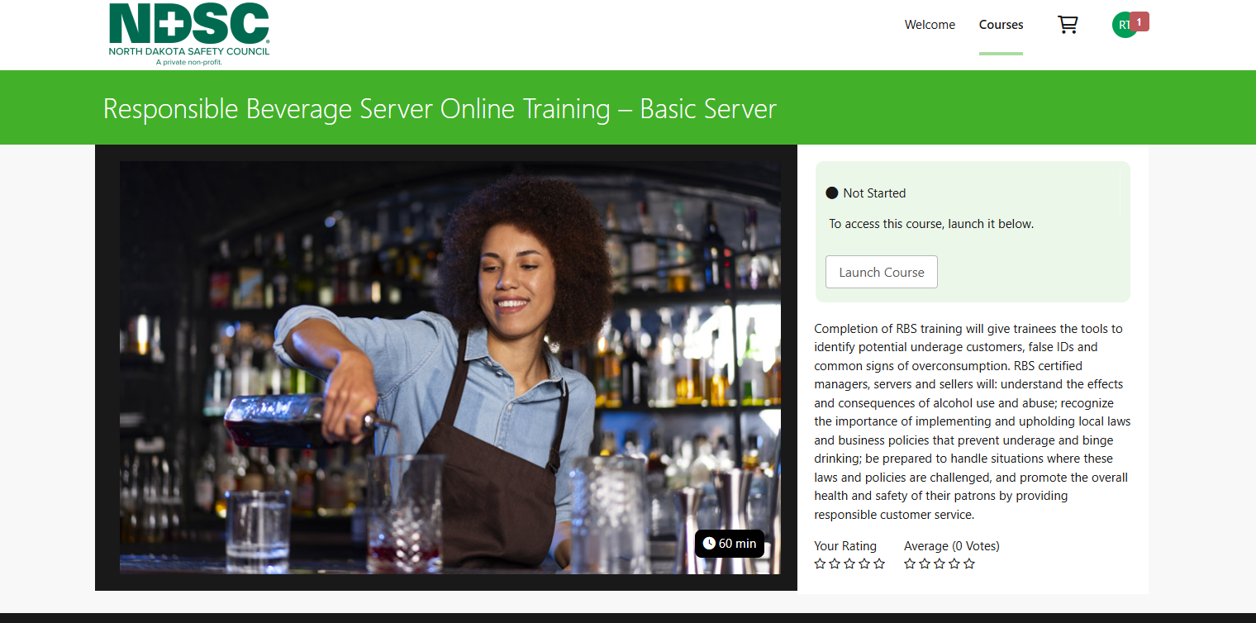

After completing the course, your certificate will be available under the Transcript tab. Print your own certificate and keep for your records.
